**A MINI PROJECT ON**

**AI BASED LEARNING PLATFORM**

IN PARTIAL FULFILLMENT OF THE REQUIREMENTS

FOR THE AWARD OF THE DEGREE IN

**BACHELOR OF COMPUTER APPLICATIONS OF**

**MAHATMA GANDHI UNIVERSITY**

**KERALA**

***Submitted By***

**ABHIN KS**

**220021089858**

Under the guidance of

**Dr. LEENA C SEKHAR**

**   
DEPARTMENT OF COMPUTER APPLICATIONS**

**(2022-2025)**

**MES COLLEGE, MARAMPALLY**

**ALUVA-5**



**DEPARTMENT OF COMPUTER APPLICATIONS**

***Certificate***

This to certify that the report entitled

**AI-Edufy**

Has been submitted by

**…………………………………………………….**

**…………………………………………………….**

In partial fulfillment of the award of the degree in

**BACHELOR OF COMPUTER APPLICATION OF**

**MAHATMA GANDHI UNIVERSITY**

During the academic year 2024-2025

Register No: ………..........

Project Guide Head of the Department

Submitted for the examination held on …………………

Examiners



**Contents**

**1. INTRODUCTION 1**

1.1. Overview of the system 2

1.2 Problem Definition and Objective 3

**2. REQUIREMENT ANALYSIS 4**

2.1 Problem definition 5

2.2 Select the software development model 5

2.3 Requirement specification includes existing system and proposed system 6

2.3.1 Justification of the proposed system 6

2.3.2 Benefits of the proposed system 7

2.4 Project planning 7

2.5 Project scheduling 8

2.6 Feasibility study 8

**3. Software Requirement Specification (SRS) 10**

3.1 Introduction 11

3.1.1 Purpose 11

3.1.2 Scope 11

3.1.3 Definitions, acronyms, and abbreviations 11

3.1.4 References 12

3.1.5 Overview 13

3.2 Overall description 13

3.2.1 Product perspective 14

3.2.2 Product functions 15

3.2.3 User characteristics 16

3.2.4 Constraints 17

3.2.5 Assumptions and dependencies 18

3.3 Specific requirements 19

3.3.1 External interfaces 20

3.3.2 Functional requirements 21

3.3.3 Performance requirements 22

3.3.4 Logical database requirements 22

3.3.5 Design constraints 23

3.3.6 Software system attributes 24

3.3.7 Organizing the specific requirements 25

3.3.8 Additional comments 26

**4. Software and hardware requirements 27**

4.1 System specifications 28

4.1.1 Hardware Specifications 28

4.1.2 SoftwareSpecification 28

**5. System Design 30**

5.1 Introduction 31

5.2 Input design 31

5.3 Output design 33

5.4 ER diagram 34

5.5 Database design 34

5.6 Module description 37

5.7 Data Flow Diagram 38

**6. System Development 40**

6.1 Process description 41

6.2 Source code 42

**7. System Implementation 48**

7.1 Testing 49

7.2 System Implementation 50

7.3 Security 51

**8. Conclusion 53**

**9. Appendix 56**

9.1 Sample input screens and outputs screens 57

**10. Bibliography 64**

**ACKNOWLEDGEMENT**

At the very outset I am very grateful to God almighty for his blessings shower upon us to complete this project. I hereby express my sincere thanks and gratitude to Prof. (Dr.) J P THAVAMANI, Principal of MES College Marampally for his kind support. I hereby express my sincere thanks and gratitude to Dr. Leena C Sekhar, Head of the Department of Computer Application MES College Marampally for her kind support throughout the course of the project

I also express my sincere thanks to Dr.Jaseena KU, Department of Computer Applications, MES College Marampally for her co-operation and Guidance throughout the course of the project work.

I also express my sincere thanks to all faculty members of the Department of Computer Applications, MES College for their timely suggestion and encouragement.

Finally, I express my heartfelt gratitude to my parents, friends, well-wishers and all who have helped me in completing this project and making this work satisfactory.

ABHIN KS

# 1. INTRODUCTION

## 1.1. Overview of the system

The Ai Bases Learning Platform (Ai-Edufy) is an interactive, AI-powered web application designed to facilitate coding problem-solving and skill development for a wide range of users. By integrating coding challenges, test cases, and AI-assisted suggestions, the platform provides an intuitive and engaging environment for learners at various skill levels to enhance their coding abilities.

At its core, Ai-Edufy empowers users to attempt coding problems while receiving suggestions from Google's Gemini AI when they encounter difficulties. The system offers multiple user roles to ensure effective management and contribution to the learning ecosystem:

* Admin: The administrator manages all administrative aspects, including user management, question management, and overall platform maintenance. They ensure the smooth operation of the system and oversee the activities of other user roles.
* Mentor: Mentors can post new coding challenges for users to solve. Their contributions fuel the continuous growth of the problem repository.
* User: Regular users engage by solving coding challenges. They earn points based on the difficulty of the problems they solve, contributing to a competitive leaderboard system. Each user has a personal dashboard that tracks their growth in various skills, the number of problems solved, and overall progress over time.

The platform is built using a robust technology stack, ensuring high performance and scalability:

* Backend: Powered by PHP, the server manages user interactions, data storage, and business logic.
* Database: MySQL serves as the database, storing all user information, problem sets, and related data.
* Frontend: The platform utilizes HTML, CSS, and JavaScript to create a responsive and user-friendly interface.
* AI Integration: Google's Gemini AI enhances the learning experience by providing real-time suggestions to users when they struggle with coding problems.

The system also includes a leaderboard feature that displays the rankings of users based on the points they accumulate by solving coding problems. This fosters a sense of competition and motivates users to continuously improve their skills.

## 1.2 Problem Definition and Objective

In today’s fast-growing tech world, learning to code has become an essential skill for personal and professional development. However, many learners struggle with maintaining motivation, finding personalized assistance, and effectively tracking their progress. Traditional coding platforms may provide challenges but often lack real-time support and feedback, which can lead to frustration and disengagement.

The Ai Bases Learning Platform (Ai-Edufy) addresses these challenges by creating a supportive environment where users can solve coding problems at their own pace. When they encounter difficulties, the platform offers AI-powered suggestions through Google’s Gemini AI, providing real-time feedback to help them overcome obstacles without needing direct human intervention. This ensures that learners can continue their coding journey without unnecessary interruptions.

Additionally, Ai-Edufy enhances the learning experience by incorporating gamification elements. Users can track their skill development and earn points for solving problems, contributing to their rank on a leaderboard. This competitive feature encourages users to challenge themselves and stay engaged, as they can compare their performance with others on the platform.

The primary objectives of Ai-Edufy are to enhance learning by providing instant AI assistance, promote skill growth through real-time progress tracking, and encourage user engagement with a leaderboard system. By combining these elements, Ai-Edufy aims to create an engaging and effective platform that supports learners in their coding journeys.

# 2. REQUIREMENT ANALYSIS

## 2.1 Problem definition

In the rapidly evolving field of technology, coding has become an essential skill for personal and professional growth. However, traditional methods of learning to code face significant challenges that hinder many learners' progress. A lack of motivation often arises from the absence of engaging and interactive learning experiences, while limited personalized support leaves learners frustrated when they encounter difficulties. Furthermore, traditional platforms provide ineffective means for tracking progress, making it hard for learners to measure their skill development or recognize their achievements. Without immediate support, learners frequently face interruptions that disrupt their ability to progress smoothly, leading to higher dropout rates and decreased confidence.

Ai-Edufyaddresses these challenges by leveraging AI-powered real-time support through Google’s Gemini AI, providing instant feedback and assistance to keep learners on track. The platform incorporates gamification elements, such as a point system and leaderboards, to maintain motivation and encourage healthy competition among users. Additionally,Ai-Edufy offers robust progress tracking, allowing learners to monitor their growth and celebrate milestones. By combining these features, Ai-Edufy creates an engaging, supportive, and effective learning environment, empowering individuals to overcome challenges and achieve success in their coding journeys.

## 2.2 Select the software development model

The software development model I followed is the Agile Model. This model emphasizes iterative development and flexibility, allowing for continuous improvement throughout the project. The process began with gathering user requirements, followed by designing a flexible architecture that could evolve as needed. After each iteration, feedback was gathered from stakeholders, and the system was improved in incremental stages. This approach allowed for frequent releases of working software, enabling me to adapt to changing requirements and ensure the project meet user needs at every stage of development. The Agile model ensured that the development process was adaptive and responsive to feedback, promoting collaboration and ongoing refinement of the system.

## 2.3 Requirement specification includes existing system and proposed system

**Existing System**

The current landscape of online coding platforms provides various challenges and exercises to help users develop programming skills. However, many of these platforms lack real-time assistance, leaving users to struggle with complex problems without adequate guidance. While some platforms offer forums or community-based solutions, these approaches often delay problem-solving and can lead to frustration. Additionally, most platforms lack personalized feedback or suggestions tailored to individual users' needs, making it difficult for learners to identify and address specific areas for improvement. The absence of a structured tracking mechanism for skill development further reduces user motivation and engagement over time.

**Proposed System**

The Ai-Edufy aims to overcome these challenges by integrating AI-powered suggestions, gamification, and real-time progress tracking. Unlike existing systems,Ai-Edufy provides instant feedback and suggestions through Google’s Gemini AI, enabling users to address their coding challenges without unnecessary delays. The platform promotes a personalized learning experience by allowing users to track their growth in various skills and receive targeted recommendations for improvement. By incorporating gamification elements like leaderboards and point systems,Ai-Edufy fosters a competitive and engaging environment that encourages continuous learning and skill enhancement

### 2.3.1 Justification of the proposed system

The Ai-Edufy addresses the critical limitations of existing coding platforms by integrating AI-powered real-time assistance, which offers personalized feedback and guidance through Google's Gemini AI. This feature ensures that learners receive instant help when encountering difficulties, minimizing frustration and preventing interruptions in their learning process. Unlike traditional platforms, which rely on delayed forums or peer-based solutions, Ai-Edufy empowers users to solve problems independently while benefiting from timely, AI-generated suggestions.

Additionally, Ai-Edufy incorporates gamification elements such as leaderboards and point systems, which foster a competitive yet supportive environment. This gamified approach encourages learners to challenge themselves and track their progress, promoting continuous engagement and skill development. The ability to monitor growth through personalized dashboards motivates users to keep improving and advancing, ensuring that the platform not only addresses immediate learning needs but also helps sustain long-term engagement and motivation.

### 2.3.2 Benefits of the proposed system

The Ai-Edufy offers numerous benefits that enhance the coding learning experience. By integrating Google’s Gemini AI, the platform provides real-time, personalized assistance, allowing users to quickly overcome obstacles without waiting for external help. This ensures uninterrupted learning and a more efficient problem-solving process. Additionally, Ai-Edufy incorporates gamification elements such as leaderboards and point systems, which foster a competitive yet motivating environment. This not only encourages users to solve more challenges but also enhances engagement by making learning fun and rewarding.

Furthermore, Ai-Edufy offers a personalized learning experience through dashboards that allow users to track their progress, monitor skill development, and identify areas for improvement. This feature enables learners to focus on specific challenges and adapt their learning path according to their individual needs. The platform is scalable, offering problems of varying difficulty levels to accommodate beginners and advanced users alike, ensuring that learners can continuously grow and improve their coding skills at their own pace.

## 2.4 Project planning

The development of the Ai-Edufy will follow a structured approach, divided into distinct phases: planning, design, development, testing, deployment, and maintenance. The planning phase will involve gathering requirements, defining the scope, identifying the target audience, and selecting the appropriate technology stack. A detailed timeline will be established to ensure smooth progress, with milestones for key deliverables.

The design phase will focus on creating user-friendly, responsive UI/UX designs. The system architecture will be planned, with emphasis on backend database design using MySQL, API integrations, and the incorporation of AI.The development phase will then begin, where front-end will build the interface using HTML, CSS, and JavaScript, while back-end will implement server-side logic with PHP and MySQL. Integration of AI-powered suggestions from Google’s Gemini AI will also be initiated during this phase.

## 2.5 Project scheduling

The Ai-Edufywill be developed over a structured timeline, divided into key phases, each with specific tasks and deadlines. The planning phase will take 2 weeks, focusing on requirement gathering, defining the project scope, selecting the technology stack, and preparing documentation. Following this, the design phase will span 4 weeks, where UI/UX wireframes and prototypes will be created, and the system architecture will be defined. The development phase is the longest, lasting 8 weeks, during which front-end and back-end development will occur, including the integration of AI-powered suggestions, database design, and API development. Finally, the testing phase will take 4 weeks, focusing on system testing, bug fixing, and user acceptance testing to ensure the platform functions as expected. This schedule provides a clear roadmap for the project, with each phase building upon the previous one to ensure timely and efficient completion.

## 2.6 Feasibility study

The feasibility of theAi-Edufy will be assessed in terms of technical, operational, economic, and legal aspects. Technical feasibility is strong, as the platform will use established technologies like PHP for backend development, MySQL for database management, and HTML, CSS, and JavaScript for the front end. The integration of Google’s Gemini AI is also technically viable, as it can be accessed through an API, providing real-time suggestions to users. The system architecture will be scalable, supporting a large user base, and the development team possesses the necessary expertise to implement these technologies efficiently.

Operational feasibility is high, as the platform is designed to be intuitive and adaptable for users across different roles, such as admins, mentors, and learners. The system’s user interface will be simple to navigate, ensuring that all users can engage with the platform effectively. Additionally, the backend will support efficient management of data and operations. In terms of economic feasibility, the project is cost-effective given the choice of open-source technologies and the existing skill set of the development team. The development timeline and budget are well-aligned with the available resources. Finally, legal feasibility has been considered, with the platform ensuring compliance with data protection laws, such as GDPR, and adhering to the necessary regulations for handling user data securely.

# 

# 3. Software Requirement Specification (SRS)

## 3.1 Introduction

Ai-Edufy addresses the unique needs of admins, mentors, and learners, creating a holistic environment for coding education. The platform's backend is developed using PHP, ensuring dynamic server-side processing, while MySQL serves as the relational database for efficient data storage and retrieval. The frontend is built using HTML, CSS, and JavaScript, delivering a responsive and intuitive user interface. Leveraging Google’s Gemini AI, Ai-Edufy offers real-time coding suggestions and problem-solving support, helping users overcome challenges effectively. The inclusion of gamified elements like leaderboards and dashboards further enhances user engagement and tracks individual progress.

### 3.1.1 Purpose

The purpose of Ai-Edufy is to provide an interactive and supportive platform for coding learners of all levels to enhance their programming skills. By integrating AI-powered real-time assistance, gamification, and progress tracking, the platform aims to address challenges like lack of motivation, limited personalized support, and ineffective progress monitoring.

### 3.1.2 Scope

The scope of Ai-Edufy encompasses providing a comprehensive, AI-driven learning platform for coding enthusiasts. It serves diverse user roles, including admins, mentors, and learners, ensuring seamless management, challenge creation, and skill development. The platform leverages Google's Gemini AI for real-time coding assistance, gamification elements like leaderboards for motivation, and personalized dashboards for progress tracking. Designed for scalability and adaptability, Ai-Edufy caters to users of varying skill levels, promoting continuous growth and engagement in their coding journeys.

### 3.1.3 Definitions, acronyms, and abbreviations

* AI: Artificial Intelligence – Technology that simulates human intelligence processes for problem-solving and learning.
* Gemini AI: A product from Google providing advanced AI capabilities, integrated into Ai-Edufy for real-time coding suggestions.
* Gamification: The application of game-like elements (e.g., points, leaderboards) to engage and motivate users.
* Admin: A platform role responsible for user management, content moderation, and system maintenance.
* Mentor: A platform role allowing users to post challenges, provide feedback, and monitor learners' progress.
* Leaderboard: A ranking system displaying users' scores based on the points earned from solving coding challenges.
* PHP: Hypertext Preprocessor – A server-side scripting language used for backend development.
* MySQL: A relational database management system used to store and manage platform data.
* Frontend: The user-facing interface of the platform, built with HTML, CSS, and JavaScript.
* Dashboard: A personalized interface for users to track their progress, monitor skills, and view achievements.
* Ai-Edufy: An AI-powered coding learning platform that integrates real-time assistance, gamification, and skill-tracking features to create an engaging and effective learning environment for users of all levels.

### 3.1.4 References

1. Google Gemini AI – Official documentation and resources on integrating AI solutions for real-time problem-solving.
2. PHP Official Website – Comprehensive resources for understanding and implementing server-side scripting.
3. MySQL Documentation – Detailed guidance on relational database management and its use in web applications.
4. W3C Standards – Guidelines and best practices for HTML, CSS, and JavaScript development.
5. Articles and Research Papers on Gamification – Insights into using gamified elements to enhance user engagement and motivation in learning platforms.
6. Software Engineering Textbooks – Reference materials on the Agile model and software development lifecycle.
7. Online Coding Platforms – Analysis and comparison of existing systems to identify limitations and define improvements for Ai-Edufy.
8. One compiler API - An online compiler API supporting multiple programming languages, used for integrating real-time code compilation and execution functionality.

### 3.1.5 Overview

Ai-Edufy is an AI-powered coding platform designed to address the challenges learners face in traditional coding environments. By combining real-time AI assistance, gamification, and personalized progress tracking, the platform offers a comprehensive learning solution for users of all levels. It features three primary user roles:

* Admins manage user accounts, oversee content, and ensure smooth platform operations.
* Mentors create coding challenges, and help maintain an engaging learning environment.
* Users solve coding problems, earn points, track skill development, and compete on leaderboards.

The system is built using a robust technology stack, including PHP for backend operations, MySQL for data storage, and HTML, CSS, and JavaScript for a responsive frontend. By leveraging Google’s Gemini AI, the platform provides personalized, real-time assistance, empowering users to overcome obstacles without delays. Gamified elements like leaderboards and point systems ensure sustained engagement and motivation, fostering a competitive yet supportive learning environment.

Ai-Edufy ultimately aims to make learning to code an engaging, efficient, and empowering experience for all users.

## 3.2 **Overall description**

The development of Ai-Edufy integrates a robust technology stack to deliver an efficient learning platform. The backend is developed using PHP for server-side logic and MySQL for managing relational data. The frontend is created with HTML, CSS, and JavaScript to provide a responsive user interface.

For advanced features, One Compiler API is used for real-time code execution, and Google Gemini AI powers intelligent, context-aware assistance. The platform is designed following scalable and modular development practices to ensure adaptability and seamless integration of additional features.

### 3.2.1 Product perspective

Ai-Edufy is an innovative learning platform designed to bridge the gap between traditional coding education methods and the needs of modern learners. It is a self-contained system that integrates seamlessly into the digital learning ecosystem, offering real-time AI support, gamified elements, and personalized dashboards.

The product differentiates itself from existing platforms in several ways:

* AI-Driven Assistance: By incorporating Google’s Gemini AI, Ai-Edufy provides instant, personalized feedback and suggestions, helping users resolve coding challenges without delays.
* Gamification: The platform introduces leaderboards, point systems, and achievement tracking to motivate users and sustain their engagement.
* Personalized Growth: Users can monitor their progress through skill-specific dashboards, which provide insights into areas of improvement and milestones achieved.

Relationship to Other Products:  
Ai-Edufy stands out by complementing existing learning tools with real-time support and engagement-focused features. Unlike static learning resources or community-based problem-solving platforms, Ai-Edufy ensures an interactive, independent, and continuously evolving user experience.

The product is developed using industry-standard technologies, ensuring compatibility and scalability to accommodate a growing user base and feature expansion. Its modular design supports future enhancements, such as integrating more advanced AI capabilities or expanding the coding problem library.

Ai-Edufy is positioned as a next-generation solution for learners seeking a dynamic and supportive coding education experience.

### 3.2.2 Product functions

Admin Functions

* User Management: Create, update, and delete user accounts and manage roles (Admin, Mentor, User).
* Question Management: Delete coding challenges submitted by mentors.
* Level management : Can create, update, delete levels.
* System Monitoring: Oversee platform performance, activity logs, and leaderboard fairness.

Mentor Functions

* Challenge Creation: Submit coding problems, including test cases and difficulty levels, for users to solve.
* Content Moderation: Review and update coding challenges to maintain the quality and relevance of the problem repository.

Learner Functions

* Problem Solving: Access a library of coding challenges, categorized by difficulty and topic, to practice and improve skills.
* AI Assistance: Utilize Google’s Gemini AI for real-time suggestions when encountering difficulties in problem-solving.
* Progress Tracking: View a personalized dashboard showing skill development, solved challenges, and earned points.
* Leaderboard Participation: Earn points by solving challenges to compete with peers on the platform’s leaderboard.

System-Wide Features

* Gamification: Incorporate leaderboards, points, and achievements to motivate and engage users.
* Real-Time Compilation: Enables users to compile and execute their code directly on the platform using an integrated compiler .
* Responsive Design: Ensure accessibility and usability across devices, including desktops, tablets, and smartphones.

### 3.2.3 User characteristics

1. Admin Characteristics

* Technical Expertise: Admins are typically experienced in platform management, databases, and backend technologies (e.g., PHP, MySQL).
* Organizational Skills: Strong ability to oversee user activity, manage content, and ensure smooth platform operations.
* Problem-Solving Abilities: Capable of addressing technical issues and maintaining the platform's integrity and security.
* Decision-Making: Admins make critical decisions about user management, challenge approval, and system updates.

2. Mentor Characteristics

* Coding Expertise: Mentors are usually experienced coders with strong problem-solving abilities across multiple programming languages.
* Teaching Ability: Ability to design and create engaging coding challenges that promote learning at various skill levels.

3. User Characteristics

* Motivation: Users are typically individuals looking to improve their coding skills, ranging from beginners to advanced learners.
* Self-Paced Learners: Users prefer the flexibility of learning at their own pace, with the ability to choose challenges based on their skill level.
* Goal-Oriented: Users seek to track their progress, gain points, and earn recognition through leaderboards, motivating them to continually improve.
* Diverse Skill Levels: The user base includes people from a variety of backgrounds, including beginners, intermediate coders, and advanced programmers.
* Engagement: Users are actively engaged in learning, enjoying both the competitive aspects (e.g., leaderboards) and the support provided by the AI assistance.

4. General Characteristics of All Users

* Technologically proficient: Users are generally comfortable using web-based platforms and have some familiarity with coding or programming languages.
* Problem-Solving Attitude: All users exhibit a willingness to face and solve coding problems, with a focus on self-improvement.
* Desire for Instant Feedback: Users seek immediate support when stuck, valuing real-time AI suggestions and progress tracking.
* Competitive: Users enjoy the gamified aspects of the platform, striving for higher rankings and accomplishments on the leaderboard.

### 3.2.4 Constraints

1. Technical Constraints

* Server Capacity: The platform’s performance is dependent on server capacity and infrastructure. Handling a large volume of users and real-time AI queries requires scalable server resources.
* Integration with External APIs: The integration of the Google Gemini AI and compiler APIs is subject to the limitations of these third-party services, including rate limits, uptime, and API response times.
* Cross-Platform Compatibility: Ensuring the platform functions consistently across different devices and browsers (desktops, tablets, and mobile) while maintaining a responsive and user-friendly interface.
* Code Execution Security: Real-time code compilation and execution must be securely sandboxed to prevent malicious code from affecting the system.

2. User Constraints

* Internet Access: The platform requires a stable internet connection for users to interact with the system, access coding challenges, and receive AI assistance.
* Coding Proficiency: Users need a basic understanding of programming to interact effectively with the system.
* Device Requirements: Users need devices that support modern web browsers and can handle the interactive features of the platform (e.g., code execution and AI suggestions).

3. Time Constraints

* Development Timeline: The platform must be developed and deployed within a predefined time frame, which may limit the number of features and refinements that can be implemented in the initial release.
* AI Response Time: There is a time constraint regarding how quickly the AI provides assistance, which should ideally be in real-time to avoid frustrating users.

### 3.2.5 Assumptions and dependencies

Assumptions

1. Stable Internet Connection: It is assumed that users will have access to a stable internet connection for seamless interaction with the platform, including receiving real-time feedback from the AI and using the code compiler.
2. Basic Programming Knowledge: Users are assumed to have some basic understanding of programming concepts and coding syntax. Ai-Edufy may not be suitable for complete beginners without any prior exposure to coding.
3. API Availability: The platform assumes that external APIs like Google’s Gemini AI and the chosen compiler API will remain available and functional during the operation of Ai-Edufy, without significant disruptions or changes in terms of service.
4. User Engagement: It is assumed that users will actively engage with the platform, solving problems, providing feedback, and utilizing AI assistance as intended.
5. Mentor Availability: It is assumed that mentors will regularly contribute new coding challenges, maintain quality standards, and offer feedback on user progress.
6. Scalability: The platform is assumed to grow over time, with the number of users and coding challenges increasing, requiring the system to be scalable to handle larger volumes of traffic and data.

Dependencies

1. Third-Party API Services:
   * Google Gemini AI: The platform’s AI-powered suggestions rely on the availability and stability of Google's Gemini AI services. Any changes or downtime in this service could impact real-time feedback functionality.
   * Compiler API : The ability to compile and run code in real-time depends on the availability and performance of the One Compiler API or other similar compiler services.
2. Web Hosting and Infrastructure: The platform’s backend and front-end services depend on reliable web hosting, cloud infrastructure, and server resources to ensure scalability, uptime, and security.
3. User Data Privacy Compliance: The platform’s operation depends on adhering to legal and regulatory requirements for user data privacy (e.g., GDPR, CCPA). Any changes in data privacy laws may necessitate adjustments in platform operations.
4. Browser and Device Compatibility: The platform relies on modern web browsers and devices (desktops, tablets, mobile) that can support its interactive features. Compatibility issues with older browsers or devices could affect user experience.
5. Community Participation: The growth of the platform depends on active contributions from mentors and the engagement of users. A lack of content or interaction could affect the platform’s success and sustainability.

## 3.3 **Specific requirements**

The Ai-Edufy platform is designed with specific requirements to ensure seamless functionality and user engagement. It features an embedded code editor integrated into the platform, allowing users to write, edit, and format code directly in their browsers. This editor supports advanced features such as syntax highlighting and error detection, while connecting with a compiler API to execute code and provide results. Communication between the frontend and backend is handled over HTTP, ensuring smooth data exchange, with platform login as a prerequisite for usage. The platform also incorporates Google’s Gemini AI to deliver AI-powered real-time feedback and coding suggestions. This integration uses a REST API over HTTPS, ensuring secure communication, with API key authentication safeguarding access. Additionally, a robust MySQL database interface is implemented to store and manage critical platform data, including user profiles, coding challenges, and progress metrics. Data interactions are conducted using SQL over TCP/IP, with authentication measures such as username and password ensuring secure access. These specific requirements collectively support the platform’s mission of providing an engaging, AI-driven learning experience.

### 3.3.1 External interfaces

1. Embedded Code Editor

* Purpose: The embedded code editor provides a user-friendly interface for writing and editing code within the platform.
* Interaction: The platform integrates an external embedded code editor that allows users to write and modify code directly in their browser. This code editor supports features like syntax highlighting, error detection, and code formatting.
* Data Exchange: The editor provides the user’s code, which is sent to the compiler API for execution or feedback.
* Protocol: HTTP for seamless communication between the frontend (code editor) and backend.
* Authentication: No authentication required for using the code editor itself, but the user must be logged into the platform to interact with the editor.

2. Google Gemini AI Interface

* Purpose: Provides real-time AI-powered feedback and suggestions to users while solving coding challenges.
* Interaction: The platform sends coding-related queries or problems from users to Google’s Gemini AI, which then returns real-time suggestions or advice.
* Data Exchange: Coding queries, problem descriptions, or user code are sent to the Gemini AI API, and the platform receives text-based feedback or suggestions.
* Protocol: REST API over HTTPS.
* Authentication: API key authentication for secure API access.

3. User Authentication and Authorization Interface

* Purpose: Manages user registration, login, and session management.
* Interaction: Users authenticate by logging in or registering via a web interface. Their credentials are validated by an authentication service, and an authentication session is returned.
* Data Exchange: User credentials (username, email, password) are sent to the authentication service, and an authentication token or session data is returned.
* Protocol: HTTPS for secure data transmission.
* Authentication: session-based authentication.

4. MySQL Database Interface

* Purpose: Stores user data, problem sets, user progress, leaderboard data, and more.
* Interaction: The platform interacts with a MySQL database to store and retrieve data such as user profiles, challenges, progress, and scores.
* Data Exchange: SQL queries are sent to the database to read or write data (e.g., inserting user progress, retrieving problems).
* Protocol: SQL over TCP/IP.
* Authentication: Username and password authentication for secure database access.

### 3.3.2 Functional requirements

1. User Registration and Authentication

The system must allow users to register and authenticate using email, and ensure secure login/logout functionality.

2. Code Editor Integration

The platform must provide an embedded code editor with features like syntax highlighting and error detection to facilitate coding directly in the browser.

3. Code Compilation and Execution

The platform must integrate a compiler API to execute the user’s code and provide the output or errors in a user-friendly format.

4. AI-Powered Assistance

The system should integrate Google’s Gemini AI to provide real-time suggestions and feedback when users face coding challenges.

5. Problem Set Management

Mentors and admins must be able to add, update, or remove coding challenges, ensuring a dynamic and categorized problem set.

6. User Dashboard

Each user should have a personalized dashboard displaying their progress, challenges solved, points earned, and performance over time.

7. Leaderboard and Gamification

The platform must include a leaderboard system that ranks users based on points earned, promoting competition and engagement.

9. User Profile Management

Users should be able to manage their personal information, upload profile pictures, and view their coding history and achievements.

10. Admin Panel

Administrators must have access to a control panel for managing user accounts, problem sets, and platform settings

### 3.3.3 Performance requirements

To ensure optimal performance, Ai-Edufy must support fast code execution with results returned within 5 seconds for simple problems and 10 seconds for complex ones, handle up to 10,000 concurrent users with seamless scalability, maintain minimal latency with sub-second response times for user interactions, use optimized database queries and scalable infrastructure to manage user data, provide real-time AI assistance with responses under 50 seconds, guarantee 99.9% uptime with redundant systems for high availability, implement caching for faster content delivery, ensure robust security with encryption and protection against attacks, and optimize resource usage to reduce server load and improve overall efficiency.

### 3.3.4 Logical database requirements

The system will use a relational database (MySQL) to store user data, coding challenges, test cases, leaderboard rankings, and user progress.

Tables:

* ADMIN: Stores information about the platform's administrators, including email , password
* USERS: Stores user information, including user ID, name, email, role (mentor, learner), password, profile_image
* QUESTIONS: Stores details of coding challenges, including question ID, title, description, type, associated mentor ID , points
* COMPLETED_QUESTIONS: Stores details of the learner_id , question_id , answer , language
* TEST_CASES: Stores the test cases associated with each coding challenge, including test case ID, question ID, input data, expected output
* LEADERBOARD: Stores user rankings based on points earned, including user ID, points, and level_id
* LEVELS: Stores information about user skill levels, including level ID,level Number, level title (eg : beginner, intermediate, expert), and associated points required.

By organizing data in these tables, the system will efficiently manage users, challenges, progress tracking, and leaderboards while ensuring smooth operation and scalability.

### 3.3.5 Design constraints

The design of Ai-Edufy adheres to key constraints to ensure functionality, scalability, and user satisfaction. The system uses a relational database (MySQL) with a normalized schema to maintain data integrity and reduce redundancy. It supports scalability with cloud-based infrastructure and server load balancing to handle increasing user demand. Performance requirements ensure low latency, with fast response times for user interactions and code compilation, aided by efficient caching strategies. Security measures include encrypted data storage, role-based access control, and secure API communication using HTTPS.

The platform is designed for compatibility across major browsers and devices, with a responsive interface for seamless use on desktops, tablets, and mobiles. It integrates a secure compiler API supporting multiple programming languages and provides real-time feedback for AI-powered suggestions. Ai-Edufy complies with data privacy regulations, ensuring user data is handled securely. Development focuses on delivering essential features like AI integration and leaderboards in the initial release, with plans for incremental updates to enhance functionality over time. These constraints ensure a reliable, secure, and user-friendly learning environment.

### 3.3.6 Software system attributes

The Software System Attributes for Ai-Edufy ensure its reliability, efficiency, and usability to meet user expectations and deliver a seamless learning experience

Reliability:  
 Ai-Edufy is designed to provide uninterrupted service, with robust error handling to minimize downtime. Automated backups and recovery mechanisms ensure data integrity and system availability even in case of failures.

Scalability:  
 The platform supports horizontal scalability, allowing it to handle increasing user loads by distributing traffic across multiple servers. This ensures consistent performance as the user base grows.

Performance:  
 Ai-Edufy ensures low response times, with fast loading pages and code compilation results provided within seconds.

Security:  
 The system employs advanced encryption for sensitive data, secure APIs, and role-based access controls to prevent unauthorized access

Usability:  
 Ai-Edufy features a user-friendly and intuitive interface, designed for easy navigation and interaction across various devices. Real-time feedback and clear visual indicators enhance the user experience.

Maintainability:  
 The platform uses modular design principles, allowing for easier updates and feature enhancements. Comprehensive documentation supports efficient debugging and system upgrades.

Portability:  
 Ai-Edufy is compatible across all major browsers and operating systems, ensuring a consistent experience for users on desktops, tablets, and mobiles.

Extensibility:  
 The system is designed to accommodate future integrations, such as adding new AI features, additional programming languages, or enhanced gamification elements, without significant rework.

### 3.3.7 Organizing the specific requirements

Functional Requirements

* User Management:
  + Allow users to register, log in, and update their profiles.
  + Support role-based access control (Admin, Mentor, Learner).
* Coding Challenges:
  + Provide a repository of coding questions categorized by difficulty.
  + Enable users to solve problems and view test case results.
* AI Assistance:
  + Integrate Google’s Gemini AI to provide real-time coding suggestions and feedback.
* Progress Tracking:
  + Display personal dashboards with skill growth, solved problems, and progress metrics.
* Gamification:
  + Implement a point system and leaderboard to foster competition among users.

Performance Requirements

* Code compilation results should be delivered within 5-10 seconds.
* Ensure sub-second response times for general user interactions.

Security Requirements

* Encrypt sensitive user data, including passwords and personal information.
* Secure all API communications with HTTPS and authentication mechanisms.

Usability Requirements

* Provide an intuitive, responsive user interface adaptable to all device types.
* Offer real-time feedback for user actions to maintain engagement.

Database Requirements

* Use MySQL for managing data with normalized tables to maintain data integrity.
* Include tables for users, admins, questions, test cases, leaderboards, and levels.

Compatibility Requirements

* Ensure compatibility with major browsers (Chrome, Firefox, Safari, Edge).
* Make the platform accessible across desktops, tablets, and mobile devices.

Scalability Requirements

* Design the system to handle increasing user loads using horizontal scaling and load balancing.

Legal and Compliance Requirements

* Comply with GDPR and CCPA for user data protection.
* Adhere to licensing terms for integrated third-party tools like AI APIs and compilers.

### 3.3.8 Additional comments

Ai-Edufy is designed to provide a seamless, engaging, and scalable learning experience for coding enthusiasts. The integration of Google’s Gemini AI ensures real-time support, bridging gaps in personalized guidance. Gamification features like leaderboards and point systems enhance motivation and engagement. The modular design allows for future updates and feature additions, ensuring the platform evolves to meet user needs effectively. User feedback will be crucial for continuous improvement and achieving the goal of fostering skill development.

# 

# 4. Software and hardware requirements

## 4.1 System specifications

System specification specifies the hardware and software configuration of the new proposed system. To develop application software, we use different types of software. The software for the development has been selected based on several factors such as: -

* Support and Stability
* Cost Effectiveness
* Development Speed
* Ability to create robust application least time

## 4.1.1 Hardware Specifications

Server Requirements

* Processor: Quad-core, 2.5 GHz or higher (e.g., Intel Xeon or AMD EPYC).
* RAM: Minimum 16 GB for efficient multitasking and handling concurrent users.
* Storage: At least 500 GB SSD for faster read/write operations and data storage.
* Network: High-speed internet connection with a bandwidth of at least 1 Gbps.

Client Requirements

* Processor: Dual-core, 2.0 GHz or higher.
* RAM: Minimum 4 GB for smooth operation.
* Storage: 200 MB of free space for browser cache and temporary files.
* Display: Resolution of 1280x720 or higher.
* Browser: Latest versions of Chrome, Firefox, Safari, or Edge.

## 4.1.2 SoftwareSpecification

Server-Side Software

* Operating System: Linux-based OS (e.g., Ubuntu 20.04 or CentOS 8).
* Backend: PHP 8.1 or higher.
* Database: MySQL 8.0 for relational data management.
* Web Server: Apache 2.4 or Nginx 1.18.
* AI Integration: Google Gemini API for real-time assistance.

Client-Side Software

* Frontend Technologies: HTML5, CSS3, JavaScript (ES6+).
* Code Editor: Embedded code editor using One Compiler API.
* Browser Support: Latest versions of Chrome, Firefox, Safari, and Edge.

Additional Tools

* Version Control: Git for code management and collaboration.
* Development Environment: IDEs like Visual Studio Code or PhpStorm.

# 

# 5. System Design

## 5.1 Introduction

The system design of Ai-Edufy focuses on creating a scalable, reliable, and user-friendly platform to facilitate interactive coding education. The design leverages modern web technologies, with the frontend built using HTML, CSS, and JavaScript for dynamic and responsive user interfaces. The backend is powered by PHP to handle dynamic page generation, user interactions, and business logic processing.

The system's architecture is modular, ensuring that components such as user management, AI assistance, gamification, and progress tracking work independently but seamlessly together. This modular design enhances maintainability and scalability. The application follows a layered architecture, with the presentation layer (frontend), application logic layer (backend), and data storage layer (database) operating harmoniously.

With the integration of Google Gemini AI for real-time assistance, and MySQL for relational data storage, Ai-Edufy ensures performance, security, and extensibility. The platform is designed to handle an expanding user base while providing a responsive and engaging experience.

## 5.2 Input design

Login form

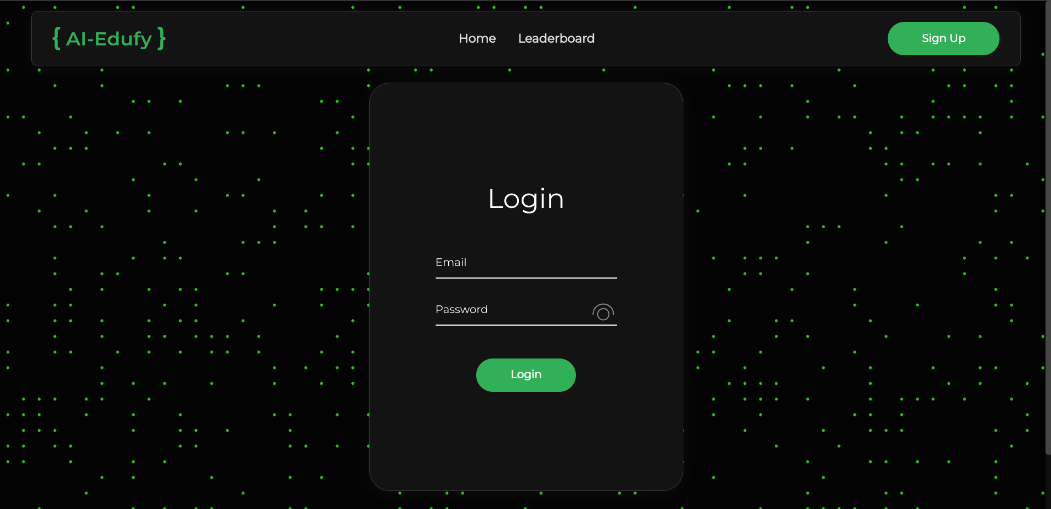

Registration form

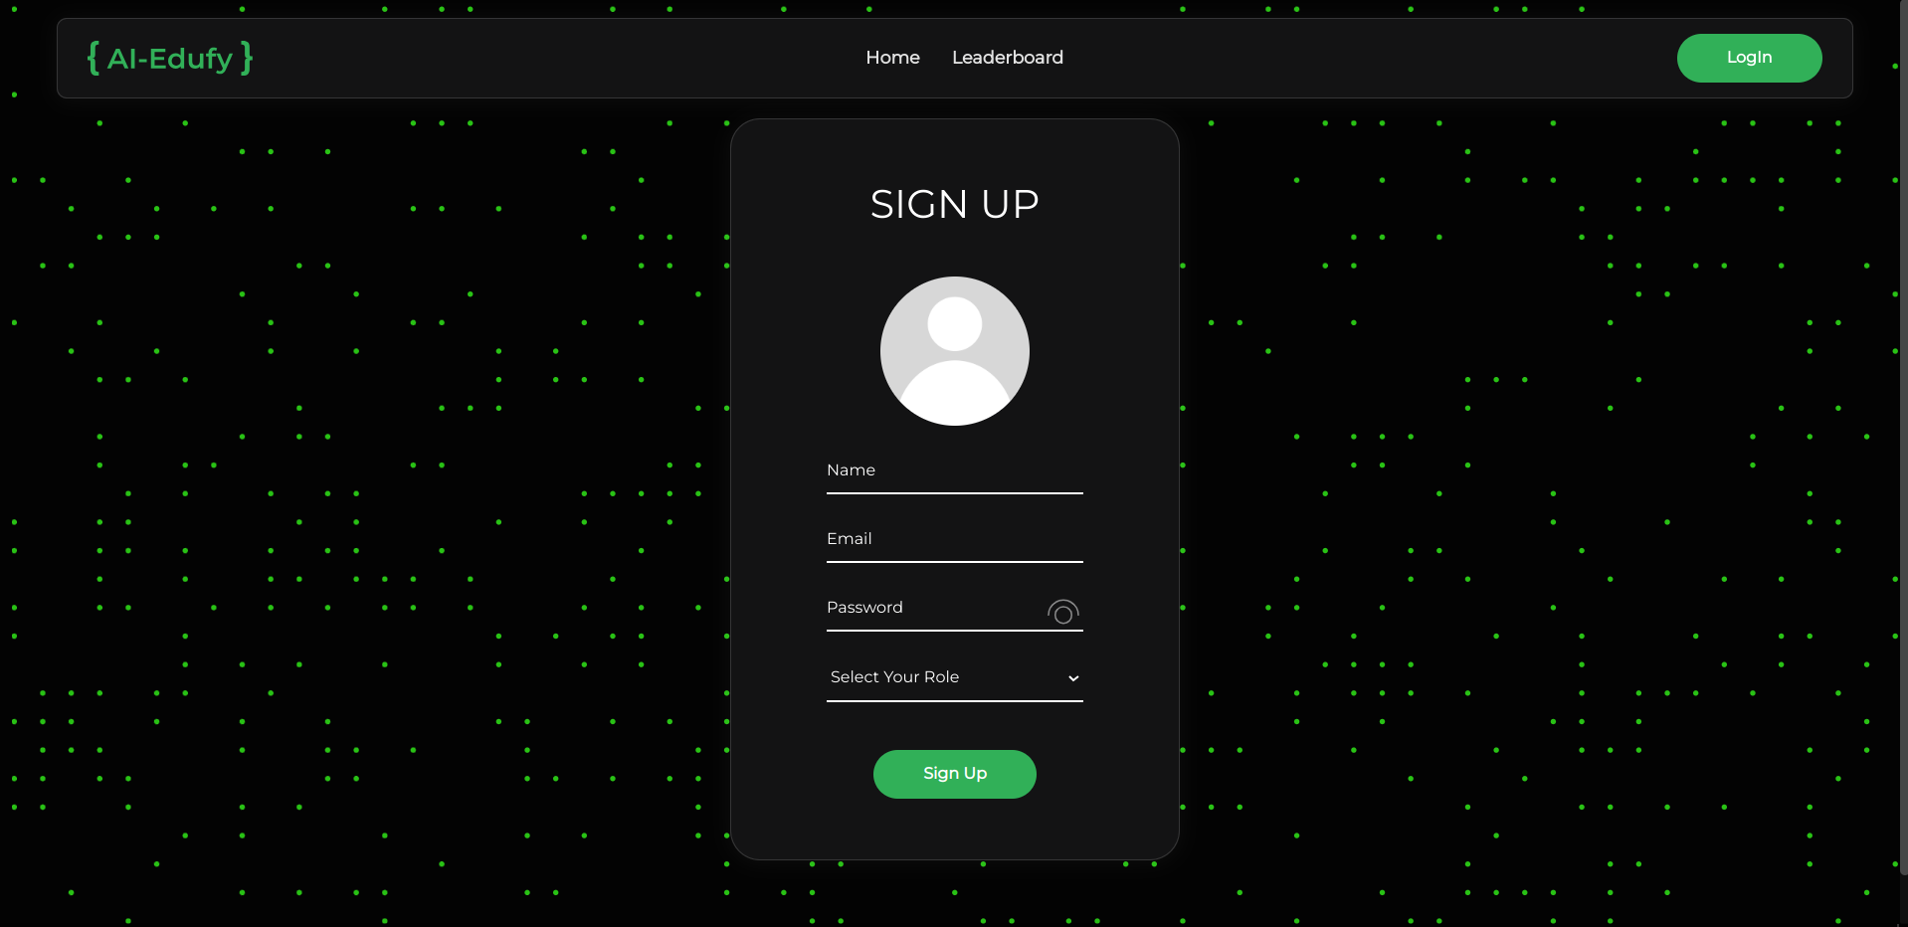

Create new question form

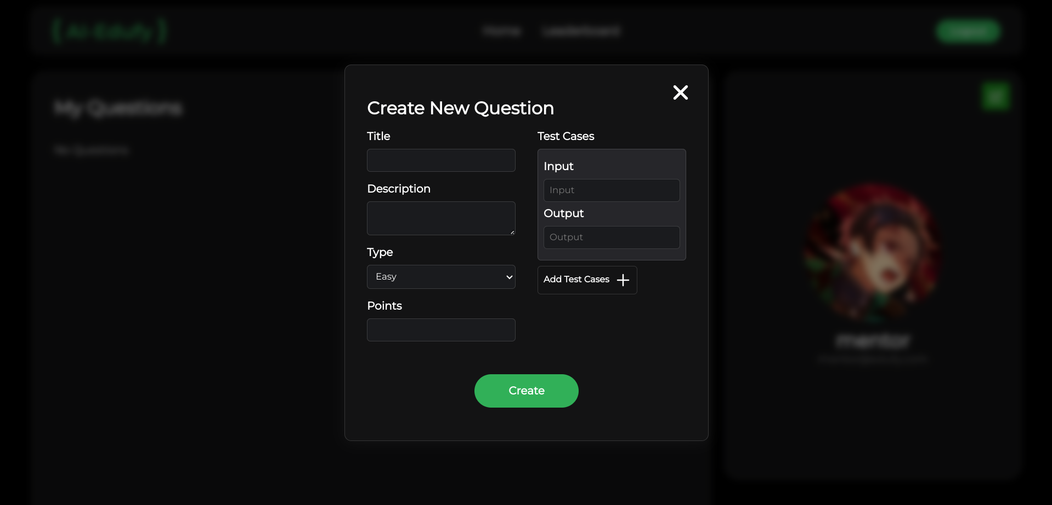

## 

## 5.3 Output design

Mentor home page

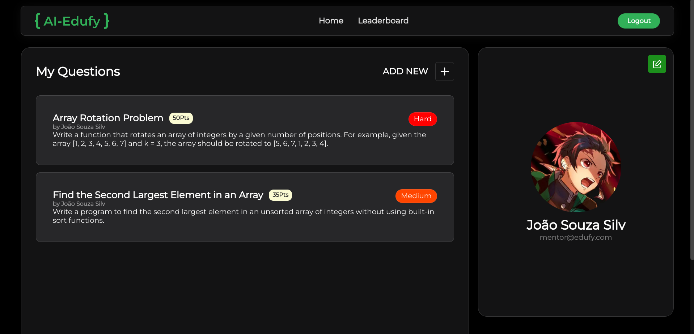

Question detail page

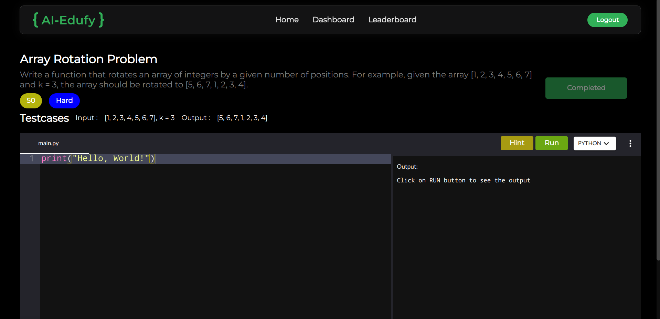

## 5.4 ER diagram

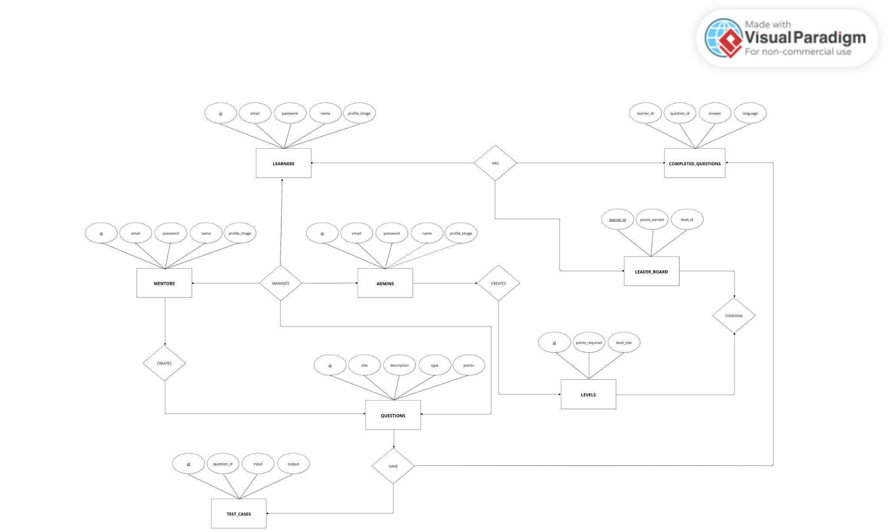

## 5.5 Database design

A database is a collection of data that can be treated as a single unit. Each individual unit within the database is called a table. In a relational database system, a table is a combination of rows and columns, where rows represent records and columns represent fields. After considerable effort, we identify the main entities, their attributes, and the relationships among them. Once these entities and relationships are defined, we design the table structure accordingly.

USERS TABLE

| FIELD | DATATYPE | CONSTRAINTS | DESCRIPTION |
| --- | --- | --- | --- |
| id | INT | PRIMARY KEY, AUTO_INCREMENT | Id of the users |
| email | VARCHAR | NOT NULL | Email of user |
| password | VARCHAR | NOT NULL | Password of user |
| name | VARCHAR | NOT NULL | Name of the user |
| role | ENUM(‘mentor’,’learner’, ‘admin’) | NOT NULL | Determine the role of the user |
| profile_image | MEDIUMBLOB | NULL | Profile image of the user |

QUESTIONS TABLE

| FIELD | DATATYPE | CONSTRAINTS | DESCRIPTION |
| --- | --- | --- | --- |
| id | INT | PRIMARY KEY, AUTO_INCREMENT | Id of the question |
| title | VARCHAR | NOT NULL | Title of the question |
| description | VARCHAR | NOT NULL | Description of the question |
| type | ENUM(easy,’medium’,’’hard’) | NOT NULL | Type of the question |
| mentor_id | INT | FOREIGN KEY | Id of the user who created this question |
| points | INT | NULL | Points get after completion of the question |

TEST_CASES TABLE

| FIELD | DATATYPE | CONSTRAINTS | DESCRIPTION |
| --- | --- | --- | --- |
| id | INT | PRIMARY KEY, AUTO_INCREMENT | Id of the question |
| input | VARCHAR | NOT NULL | Title of the question |
| output | VARCHAR | NOT NULL | Description of the question |
| question_id | INT | FOREIGN KEY | Id of the question this test case belongs to |

COMPLETED_QUESTIONS TABLE

| FIELD | DATATYPE | CONSTRAINTS | DESCRIPTION |
| --- | --- | --- | --- |
| learner_id | INT | FOREIGN KEY | Id of the user who completed the question |
| question_id | INT | FOREIGN KEY | Id of the question completed |
| answer | MEDIUMTEXT | NOT NULL | Answer of the user for that question |
| language | VARCHAR | NOT NULL | Language used to answer the question |

LEVELS TABLE

| FIELD | DATATYPE | CONSTRAINTS | DESCRIPTION |
| --- | --- | --- | --- |
| id | INT | PRIMARY KEY, AUTO_INCREMENT | Id of the level |
| level_title | VARCHAR | NOT NULL | Title of the level |
| points_required | INT | NOT NULL | Points required for the level |

LEADER_BOARD TABLE

| FIELD | DATATYPE | CONSTRAINTS | DESCRIPTION |
| --- | --- | --- | --- |
| learner_id | INT | PRIMARY KEY, AUTO_INCREMENT | Id of the learner |
| points_earned | VARCHAR | NOT NULL | Points earned by the learner by completing questions |
| level_id | INT | FOREIGN KEY | Id of the level of leaner |

## 5.6 Module description

The Ai-Edufy platform is divided into three main modules, each tailored to the specific needs and responsibilities of different user roles: Admin, Learner, and Mentor.

1. Admin Module  
   The Admin module is designed to provide administrators with complete control over the platform. It allows admins to manage user accounts, assign roles, and oversee the creation and moderation of coding problems and test cases. The module also provides administrative tools for managing the leaderboard, reviewing feedback, and ensuring the platform runs smoothly. Administrators can manage data, monitor user activity, and make adjustments to maintain a secure and functional environment for all users.
2. Learner Module  
   The Learner module is focused on providing an engaging and supportive learning experience. Learners can register, log in, and attempt coding problems from various difficulty levels. They receive real-time assistance from Google's Gemini AI, offering personalized feedback and hints when they struggle with challenges. The module also includes progress tracking features, where learners can view their skill development, see the points they’ve earned, and monitor their rank on the leaderboard.
3. Mentor Module  
   The Mentor module allows mentors to contribute to the platform by creating and managing coding challenges for learners. Mentors can add new problems, define test cases, and provide feedback to learners. They can monitor the progress of learners, answer queries, and offer support when necessary. This module is designed to enable mentors to effectively engage with learners, guide them through challenges, and help them improve their coding skills.

## 5.7 Data Flow Diagram

* Level 0

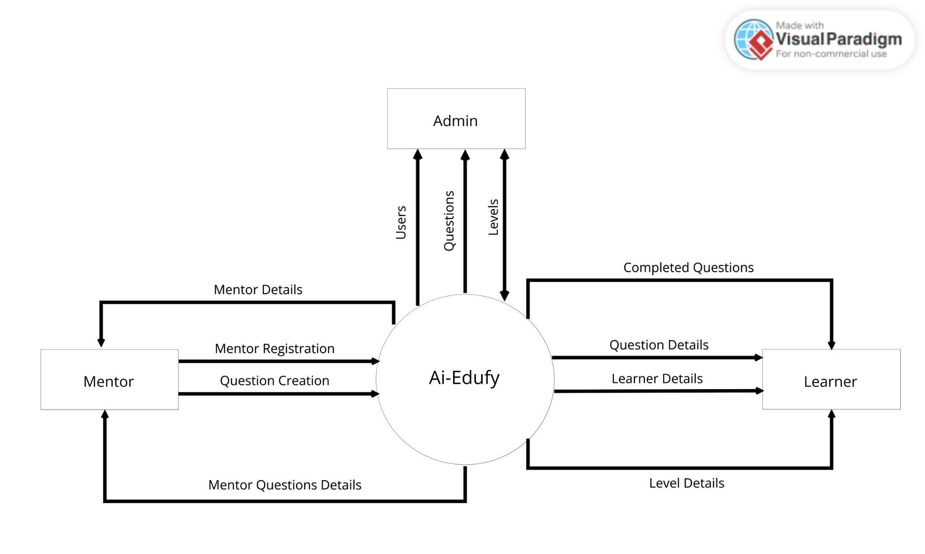

* Level 2

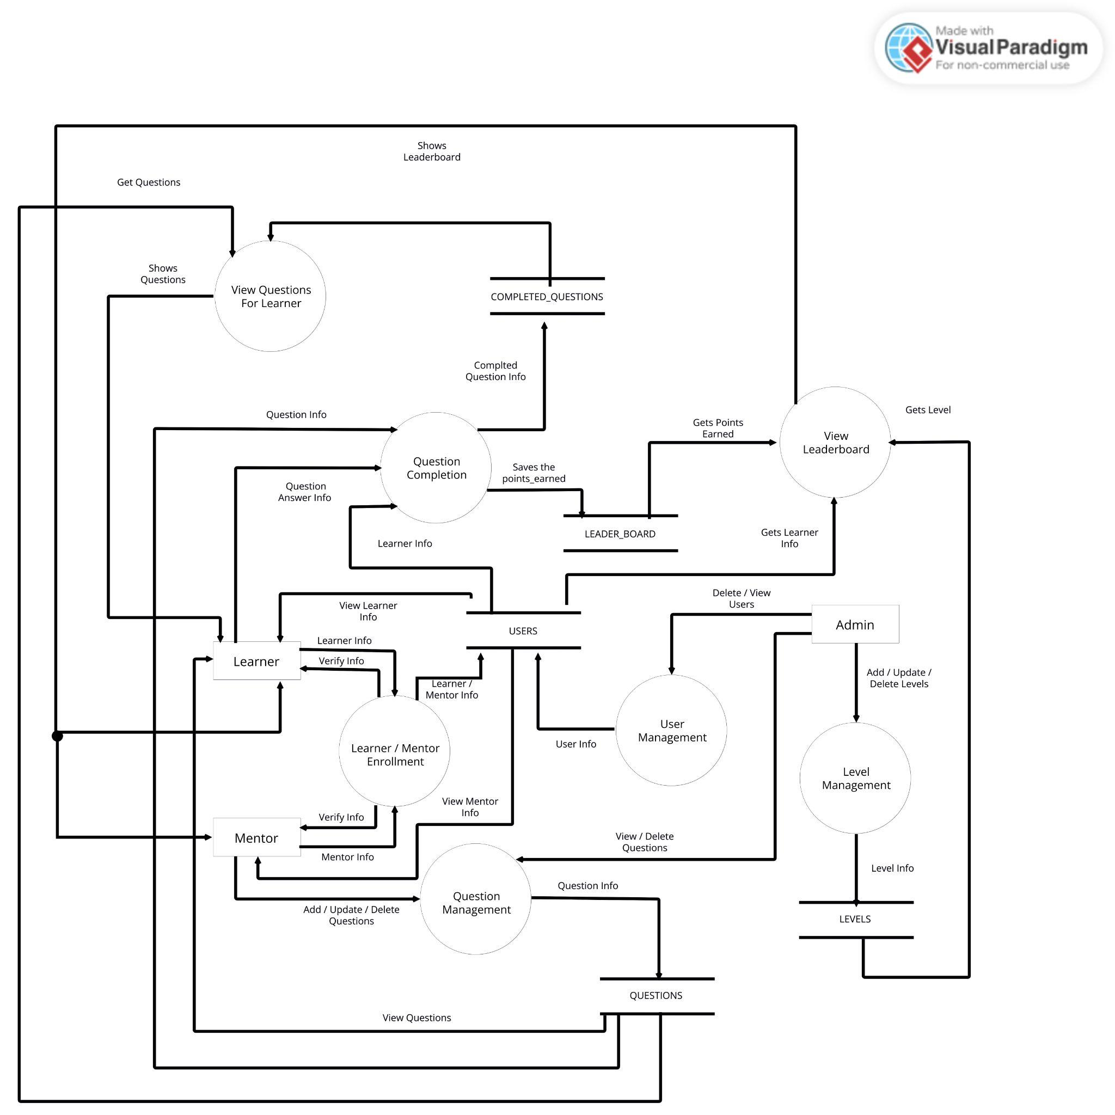

# 6. System Development

## 6.1 Process description

The development process for Ai-Edufy followed a structured approach to ensure the project met its objectives efficiently while maintaining high-quality standards. The process was based on the Agile Model, involving iterative phases to continuously improve and refine the platform. Below is the detailed development process:

1. Requirement Gathering:  
    The first phase involved collecting and analyzing user requirements for the Admin, Mentor, and Learner modules. Stakeholder needs were identified through interviews and discussions to ensure the system would cater to all user roles effectively. This step was crucial for understanding the unique needs of each user type and defining the core features of the platform.
2. System Design:  
    The design phase included the development of high-level and detailed system designs, including:  
   * Database Schema to structure and organize the data.
   * Entity-Relationship (ER) Diagrams to model the relationships between various data entities.
   * Data Flow Diagrams (DFD) to visualize the flow of data within the system.
   * Module Descriptions outlining the functionality of the Admin, Mentor, and Learner modules, ensuring a clear understanding of system interactions.
3. Implementation:
   * Frontend Development: The user interfaces for Admin, Mentor, and Learner modules were developed using HTML, CSS, and JavaScript to create dynamic, user-friendly pages and ensure a responsive and engaging experience for all users.
   * Backend Development: The backend was developed using PHP for server-side processing, and MySQL for managing user data, coding challenges, leaderboard information, and other critical system components.
   * Integrated features such as form validation, data security, and role-based access control to ensure safe and efficient user interactions across the platform.
4. Testing:
   * Conducted unit testing to check individual components of the system for accuracy and functionality.
   * Performed integration testing to ensure all modules worked together seamlessly.
   * Conducted user acceptance testing (UAT) to validate that the system met user expectations and performed well under various real-world conditions.
5. Maintenance:
   * Established a maintenance plan for regular updates, bug fixes, and the addition of new features based on user feedback and platform performance.
   * Ensured that ongoing improvements, such as incorporating new coding challenges and AI model updates, were handled promptly to maintain platform engagement and quality.

## 6.2 Source code

Welcome Page

| **<html lang="en"> <head>  <meta charset="UTF-8">  <meta name="viewport" content="width=device-width, initial-scale=1.0">  <link rel="stylesheet" href="../styles/global.css" />  <link rel="stylesheet" href="../styles/home-section.css">  <script src="../scripts/welcome.js" defer></script>  <title>Document</title> </head>  <body>  <?php include ('../common/header.php') ?>  <section class="home-section">  <div class="title">  UNLOCK YOUR CODING <br> &lt;<span></span>/&gt;  </div>   <div class="hero-image-container">  <img src="../public/images/hero-image.svg" alt="hero-image">  </div>  </section> </body>  </html>** |
| --- |

Sign Up Page

| **<!DOCTYPE html> <html lang="en">  <head>  <meta charset="UTF-8" />  <meta name="viewport" content="width=device-width, initial-scale=1.0" />  <link rel="stylesheet" href="../styles/global.css" />  <link rel="stylesheet" href="../styles/login-signup.css" />  <script src="../scripts/login-signup.js" type="module" defer></script>  <title>Sign Up</title> </head>  <body>  <?php  include ('../common/header.php');  include ('../common/Toast.php');  ?>  <main>  <form class="auth-form signup" method="post">  <img src="../public/logo.svg" alt="logo" class="logo" />  <p class="title">SIGN UP</p>  <div class="inputs-container">  <input type="file" name="image" id="image-input" class="hidden" />   <div class="image-input-container">  <label for="image-input" class="image-input">  <img src="../public/images/no_proile.png" alt="image" id="image-show" />  </label>  </div>   <input class="form-input" type="text" name="name" placeholder="Name" />  <input class="form-input" type="email" name="email" placeholder="Email" />  <div class="password-container">  <input class="form-input" type="password" name="password" placeholder="Password" />  *<!-- eye images -->*  <div class="eye-container">  <img class="eye-open eye" src="../public/icons/eye-open.svg" alt="eye-open" />  <img class="eye-closed eye hidden" src="../public/icons/eye-closed.svg" alt="eye-closed" />  </div>  </div>   <select name="role">  <option value="">Select Your Role</option>  <option value="learner">Learner</option>  <option value="mentor">Mentor</option>  </select>   </div>  <button class="submit" type="submit">Sign Up</button>  </section>  </form>  </main> </body>  </html>** |
| --- |

Login Page

| **<!DOCTYPE html> <html lang="en">  <head>  <meta charset="UTF-8" />  <meta name="viewport" content="width=device-width, initial-scale=1.0" />  <link rel="stylesheet" href="../styles/global.css" />  <link rel="stylesheet" href="../styles/login-signup.css" />  <script src="../scripts/login-signup.js" type="module" defer></script>  <title>Login</title>  </head>   <body>  <?php  include('../common/header.php');  include('../common/Toast.php');  ?>  <main>  <form class="auth-form login" method="post">  <img src="../public/logo.svg" alt="logo" class="logo" />  <p class="title">Login</p>  <div class="inputs-container">  <input  class="form-input"  type="email"  name="email"  placeholder="Email"  />  <div class="password-container">  <input  class="form-input"  type="password"  name="password"  placeholder="Password"  />  *<!-- eye images -->*  <div class="eye-container">  <img  class="eye-open eye"  src="../public/icons/eye-open.svg"  alt="eye-open"  />  <img  class="eye-closed eye hidden"  src="../public/icons/eye-closed.svg"  alt="eye-closed"  />  </div>  </div>  </div>  <button class="submit" type="submit">Login</button>  </form>  </main>  </body> </html>** |
| --- |

LeaderBoard Page

| **<?php  include_once("../utils/connect.php");  $role = $_COOKIE['role'] ?? ''; $userId = $_COOKIE['user_id'] ?? '';  $leaderboard = $user->leaderboard->select('*', '', 'points_earned DESC');  $leaderboardData = [];  if (mysqli_num_rows($leaderboard) > 0) {  while ($row = mysqli_fetch_assoc($leaderboard)) {  $leaderboardData[] = $row;  } }  foreach ($leaderboardData as $key => $data) {  $learner = $user->users->select('email , profile_image , name', "id = {$data['learner_id']}")->fetch_assoc();  $leaderboardData[$key]['email'] = $learner['email'];  $leaderboardData[$key]['profile_image'] = $learner['profile_image'];  $leaderboardData[$key]['name'] = $learner['name']; }  foreach ($leaderboardData as $key => $data) {  $level = $user->leaderboard->levels->select('level_title', "points_required <= {$data['points_earned']}", 'points_required DESC')->fetch_assoc();  $leaderboardData[$key]['level_title'] = $level['level_title']; }   ?> <!DOCTYPE html> <html lang="en">  <head>  <meta charset="UTF-8">  <meta name="viewport" content="width=device-width, initial-scale=1.0">  <link rel="stylesheet" href="../styles/global.css">  <link rel="stylesheet" href="../styles/leaderboard.css">  <title>Leaderboard</title> </head>  <body id="leaderboard">  <?php  if ($role == 'mentor') {  include '../users/mentor/header.php';  } else if ($role == 'learner') {  include '../users/learner/header.php';  } else {  include '../common/header.php';  }  ?>   <main class="container">   <?php if (count($leaderboardData) > 0): ?>  <table>  <thead>  <tr>  <th>Rank</th>  <th>Profile</th>  <th>Name</th>  <th>Email</th>  <th>Points</th>  <th>Level</th>  </tr>  </thead>  <tbody>  <?php foreach ($leaderboardData as $key => $data): ?>  <tr>  <td class="rank">#<?php echo $key + 1 ?></td>  <td class="user-image">  <img src="<?php echo base64($data['profile_image']); ?>" alt="profile" />  </td>  <td class="user-name"><?php echo $data['name'] ?>  <?php if ($data['learner_id'] == $userId)  echo "(You)"; ?>  </td>  <td class="user-email"><?php echo $data['email'] ?></td>  <td class="user-points"><?php echo $data['points_earned'] ?></td>  <td class="level-title"><?php echo $data['level_title'] ?></td>  </tr>  <?php endforeach; ?>  </tbody>  </table>  <?php else: ?>  <div class="no-data">No data available</div>  <?php endif; ?>   </main>  </body>  </html>** |
| --- |

# 7. **System Implementation**

## 7.1 Testing

The testing phase for the Ai-Edufy platform was essential to ensure that the system functioned as intended and met the project’s requirements. The testing process followed an organized approach to identify and resolve issues early and ensure a smooth user experience. It consisted of several stages:

1. Unit Testing:  
   Unit testing was carried out on individual components of the system, such as the Admin, Mentor, and Learner modules. Each module's functionality was tested in isolation to ensure that all features worked as expected and to catch any bugs in the initial stages of development.
2. Integration Testing:  
   After successful unit testing, the modules were integrated, and integration testing was performed to ensure that they worked together seamlessly. This stage focused on testing the interaction between the front-end (HTML, CSS, JavaScript) and back-end (PHP, MySQL) components, ensuring data was correctly exchanged and displayed across the platform.
3. System Testing:  
   System testing was done to validate the complete functionality of the platform as a whole. This testing phase ensured that all modules worked together as expected and met the functional and non-functional requirements, including system performance, security, and data integrity.
4. User Acceptance Testing (UAT):  
   UAT was conducted with real users, such as administrators, mentors, and learners. The goal was to ensure that the platform met user expectations and provided a seamless and intuitive experience. Feedback from these users helped to identify usability issues and areas for improvement.
5. Performance Testing:  
   Performance testing was conducted to ensure that the system could handle a large number of concurrent users, ensuring that the platform remained responsive and stable under heavy load.
6. Security Testing:  
   Security testing focused on identifying vulnerabilities in the system, including potential threats such as SQL injection, cross-site scripting (XSS), and data breaches. The platform was tested for robust user authentication, role-based access control, and encryption of sensitive data.
7. Regression Testing:  
   Whenever new features were added or changes were made, regression testing ensured that existing functionality was not broken and that the platform continued to perform as expected without introducing new issues.

## 7.2 System Implementation

The implementation of the Ai-Edufy platform involved deploying the system to a live environment and ensuring it was accessible for all user roles, including Admins, Mentors, and Learners. The key steps in the implementation process were as follows:

1. Setting Up the Server: The system was deployed on a cloud-based server to ensure remote access from various locations and to provide scalability. A Linux-based web server (Apache) was selected for deployment, offering a reliable and secure hosting environment. The MySQL database was configured on the server to store critical system data, including user details, questions, test cases, leaderboard data, and coding submissions.
2. System Installation: The web application files, including HTML, CSS, JavaScript, and PHP files, were uploaded to the server using a direct deployment tool(XAMPP). Database tables were created on the MySQL server using SQL scripts to ensure the correct structure for storing data related to users, questions, answers, leaderboard rankings, and other system-related information. Admin credentials were provided to the system administrator for further configuration, user management, and system monitoring. The admin was granted full access to manage users, questions, test cases, and system settings.
3. User Training: Training sessions were conducted for the Admins, Mentors, and Learners to ensure they understood how to use the system and perform their respective tasks effectively.  
   * Admin Training: Admin users were trained on managing user roles, handling user accounts, managing questions, and monitoring the overall platform performance.
   * Mentor Training: Mentors were educated on how to post new coding questions, review submissions, and assist learners with solving problems.
   * Learner Training: Learners were shown how to browse through coding challenges, submit solutions, view feedback, and track their progress on the leaderboard.
4. Documentation was provided for each role, outlining the system features and offering troubleshooting tips for common issues.

## 7.3 Security

Security is a crucial component of the Ai-Edufy platform to protect sensitive user data, including personal information, coding submissions, progress tracking, and leaderboard information. Several robust security measures have been implemented to ensure safe user interactions and safeguard the system:

1. Authentication and Role-Based Access Control (RBAC):
   * Role-Specific Access: Each user (Admin, Mentor, and Learner) has a unique login, and the system enforces role-based access control (RBAC) to ensure users can only access data and features relevant to their role.
     + Example: Admins have full access to manage users, questions, and system settings, Mentors can only manage coding challenges and assist Learners, and Learners can browse questions, submit solutions, and track their progress.
   * Secure Login: Users authenticate using a secure combination of email and password. Passwords are stored securely in the database using strong hashing algorithms to prevent unauthorized access.
2. Data Encryption:
   * Data Encryption at Rest and in Transit: Sensitive data such as passwords, user details, and submission data are securely stored using encryption and hashing algorithms .
3. Input Validation and Security:
   * Form Validation and Sanitization: All user inputs (e.g., registration forms, code submissions) are validated to ensure that only valid data is entered. Server-side validation protects against SQL injection, cross-site scripting (XSS), and other attacks.
     + Example: All input fields are sanitized before being submitted to the database to prevent malicious code execution.
4. Database Security:
   * Restricted Database Access: The MySQL database is secured with restricted access controls, ensuring that only authorized system components and administrators can interact with it. Specific roles (Admin, Mentor, Learner) have access to their relevant portions of the database to protect sensitive data.

# 

# 8. Conclusion

The Ai-Edufy platform was built to revolutionize the way users engage with coding education. With its integration of Google’s Gemini AI, the platform offers personalized learning experiences by providing AI-powered suggestions when learners encounter challenges. This feature not only helps users solve coding problems but also enhances their overall problem-solving ability, making learning more interactive and adaptive to individual needs. The platform’s incorporation of a leaderboard and levels system further gamifies the experience, encouraging users to track their progress and compete, which adds motivation and fosters a sense of accomplishment.

Developed using the Agile Model, the system evolved in phases, with constant user feedback and iteration to refine the platform’s features and functionalities. Each user role, including Admins, Mentors, and Learners, was designed with specific needs in mind, ensuring that all interactions within the system are streamlined and role-appropriate. For instance, Admins have full control over managing users and content, while Mentors are empowered to provide assistance and guidance. Learners can access coding problems, receive AI-based suggestions, and monitor their skill development through the system.

Security has been a cornerstone of the development process. To ensure the integrity and confidentiality of user data, the platform implements role-based access control (RBAC), where permissions are granted based on the user's role, ensuring restricted access to sensitive information. Additionally, data encryption both in transit and at rest, along with regular security audits, ensures that personal information remains protected, and the platform is resilient against common vulnerabilities. The use of input validation and SQL injection prevention further safeguards the system from malicious attacks, ensuring a safe environment for all users.

The infrastructure of Ai-Edufy is built for scalability and high performance. The platform is hosted on a cloud-based server, ensuring that it can handle an increasing number of users and growing data requirements as the platform expands. This cloud-based architecture also ensures accessibility from various locations, supporting a global user base. The system is optimized to deliver fast responses, minimize downtime, and provide a seamless experience for users, regardless of location or device.

In conclusion, Ai-Edufy is a comprehensive, secure, and user-centered platform that offers a unique approach to learning coding. By integrating AI-driven support, gamification elements, and a strong security framework, it provides a dynamic and safe environment for skill development. As the platform continues to evolve, it is poised to become a leading resource for learners seeking to improve their coding abilities, while offering educators and mentors the tools to guide and assess student progress effectively.

# 9. **Appendix**

## 9.1 Sample input screens and outputs screens

Welcome Page

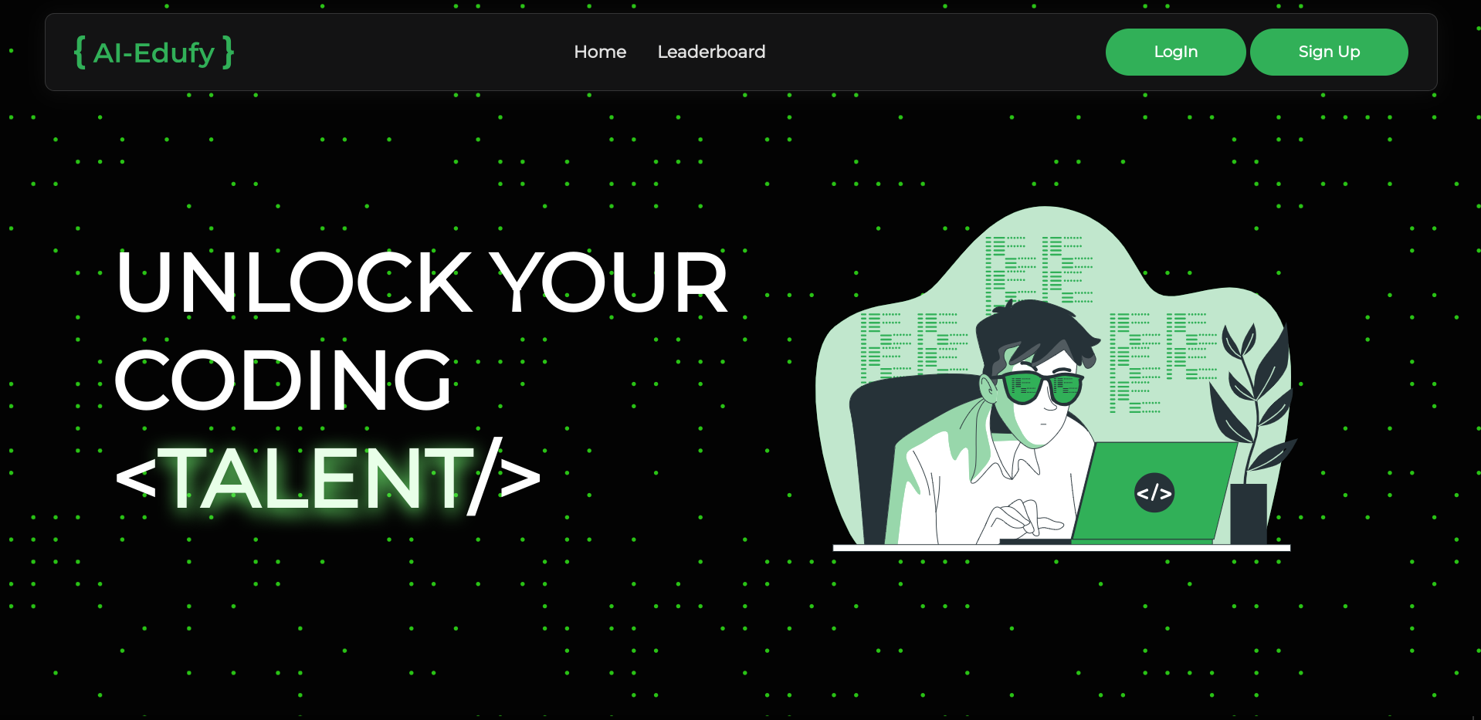

Leaderboard Page

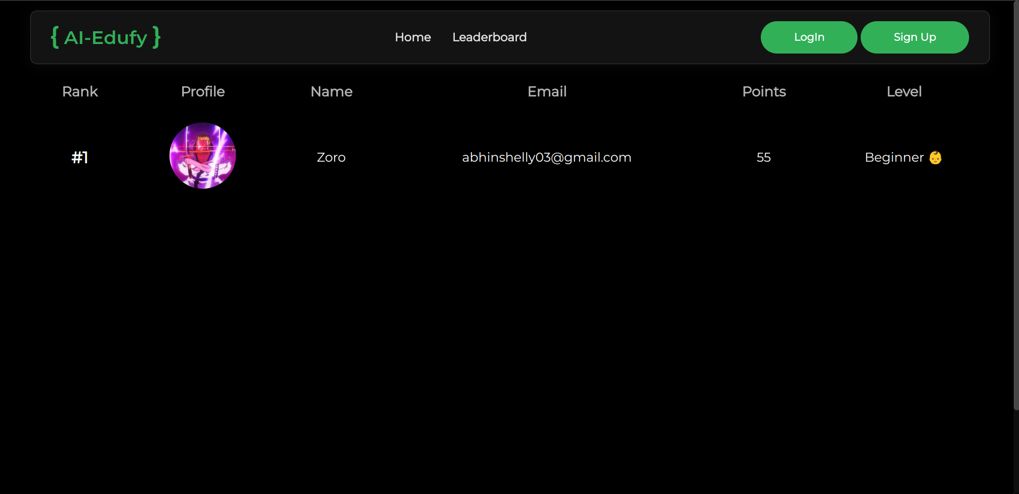

Login Page

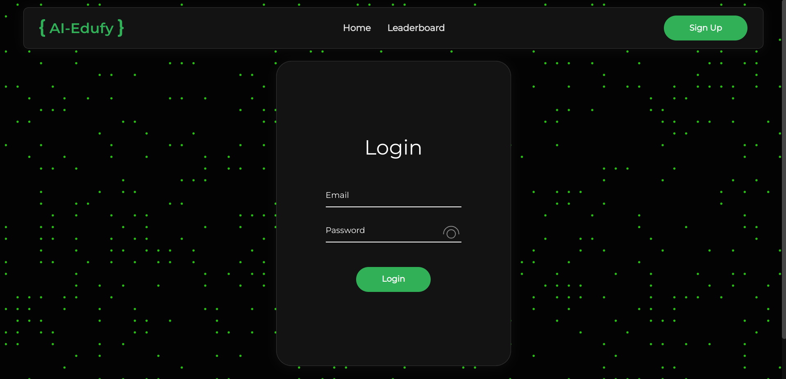

Register Page

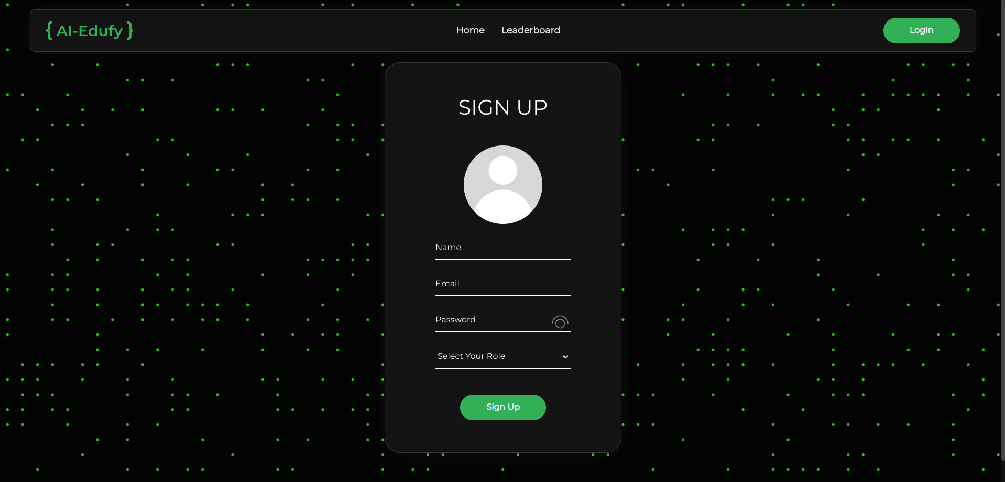

Mentor Home Page

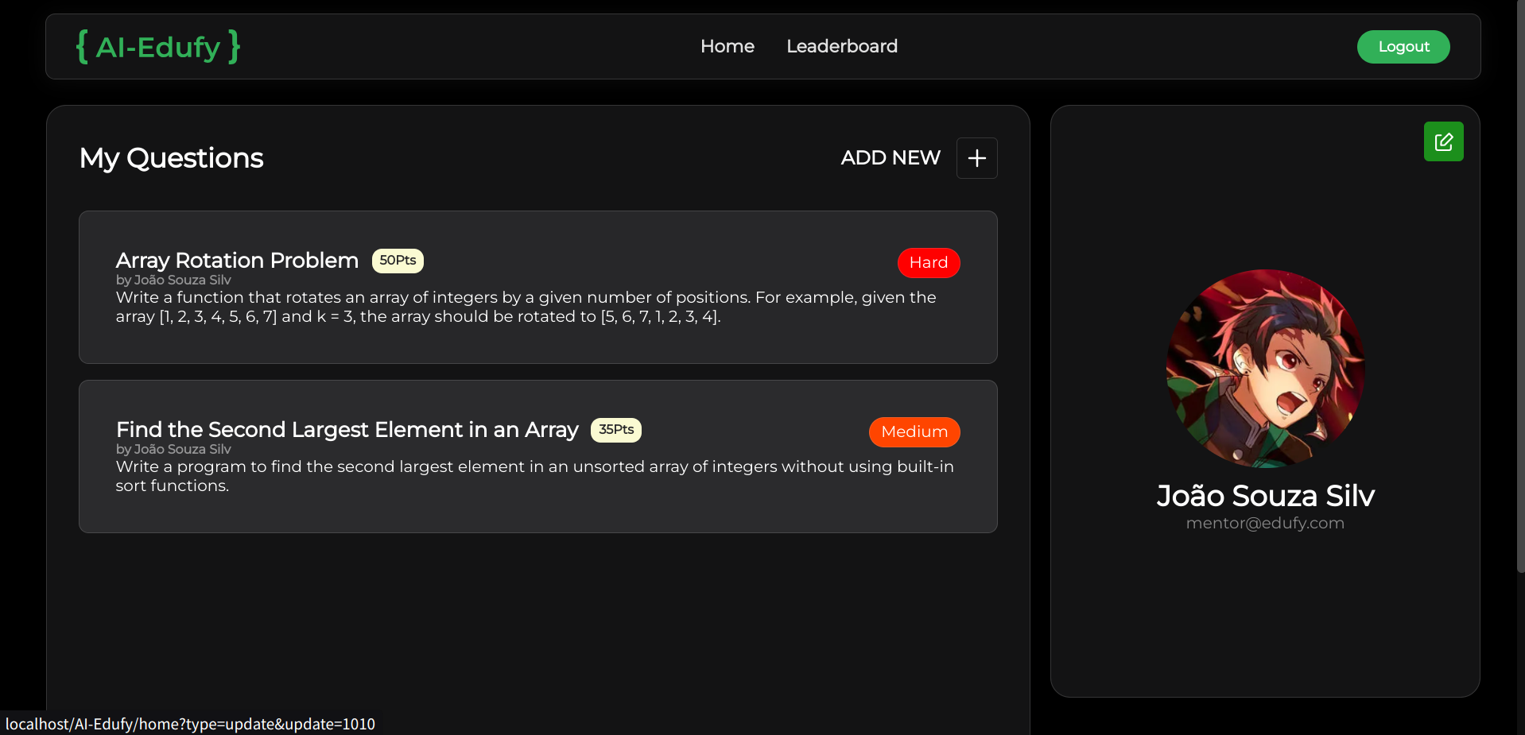

Learner Home Screen

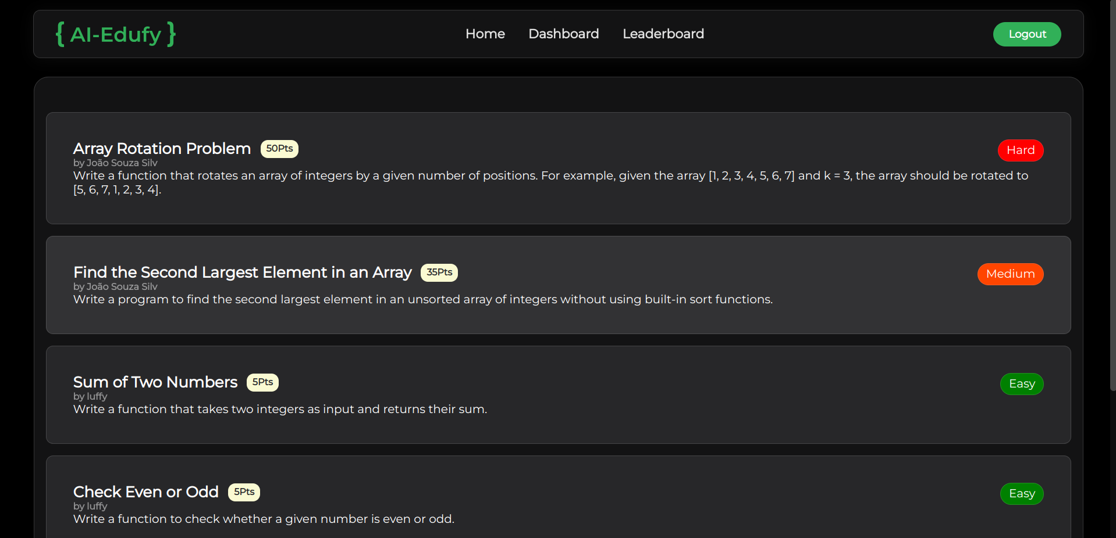

Learner Dashboard Page

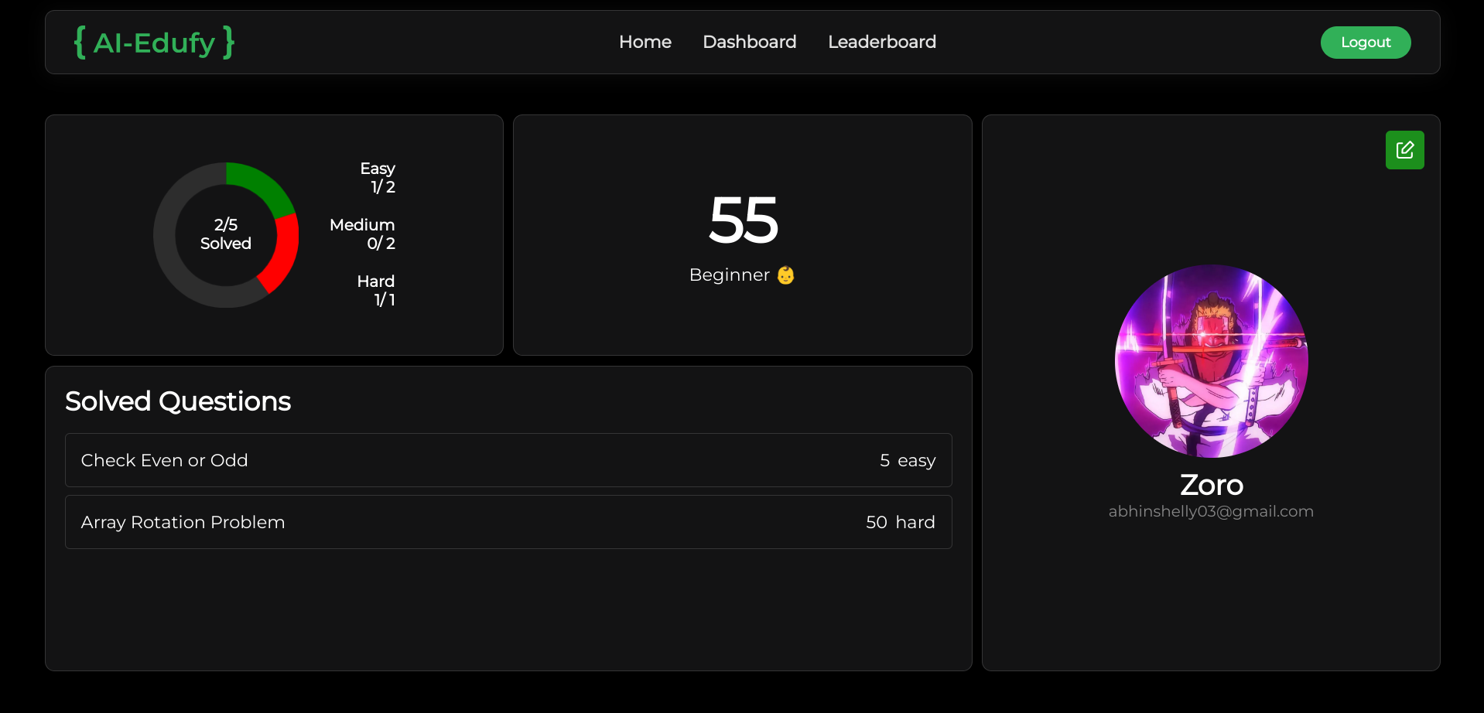

Question Details Page

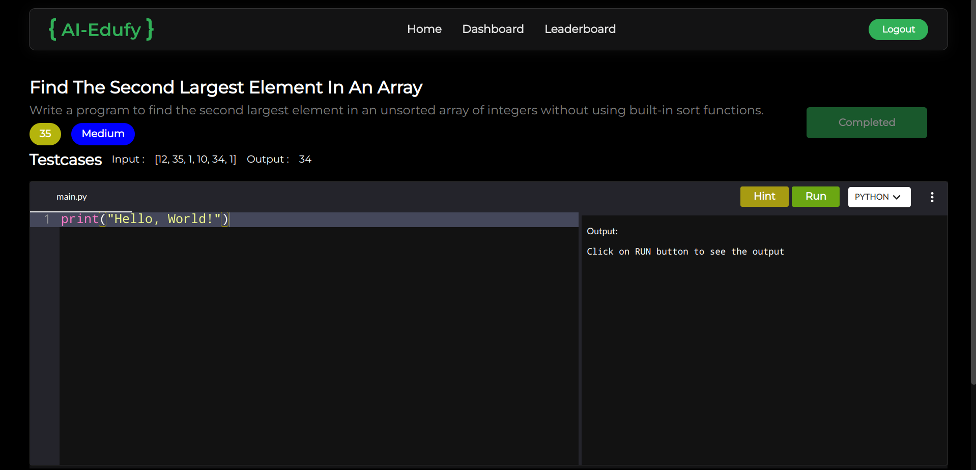

Create new Question Form



Edit User Profile Form

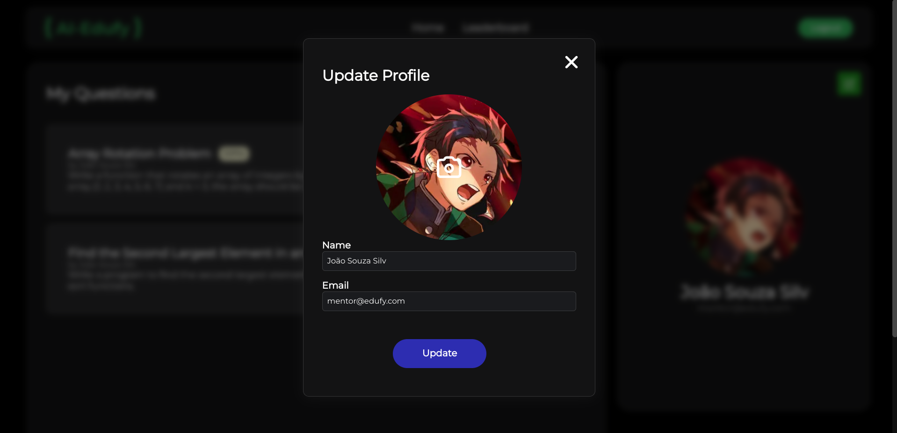

Admin User Management Page

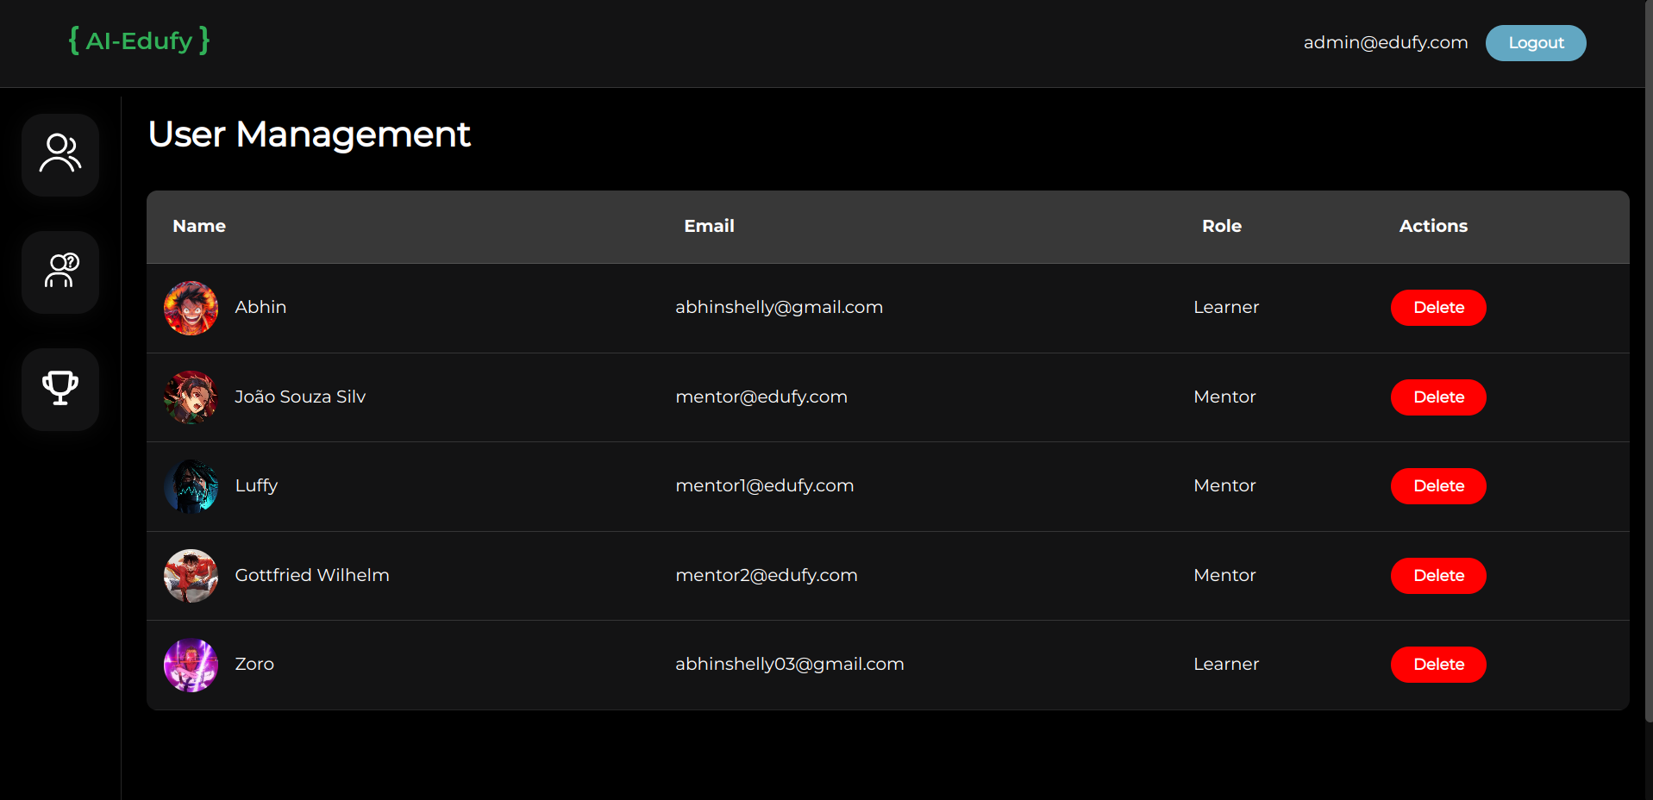

Admin Question Management Page

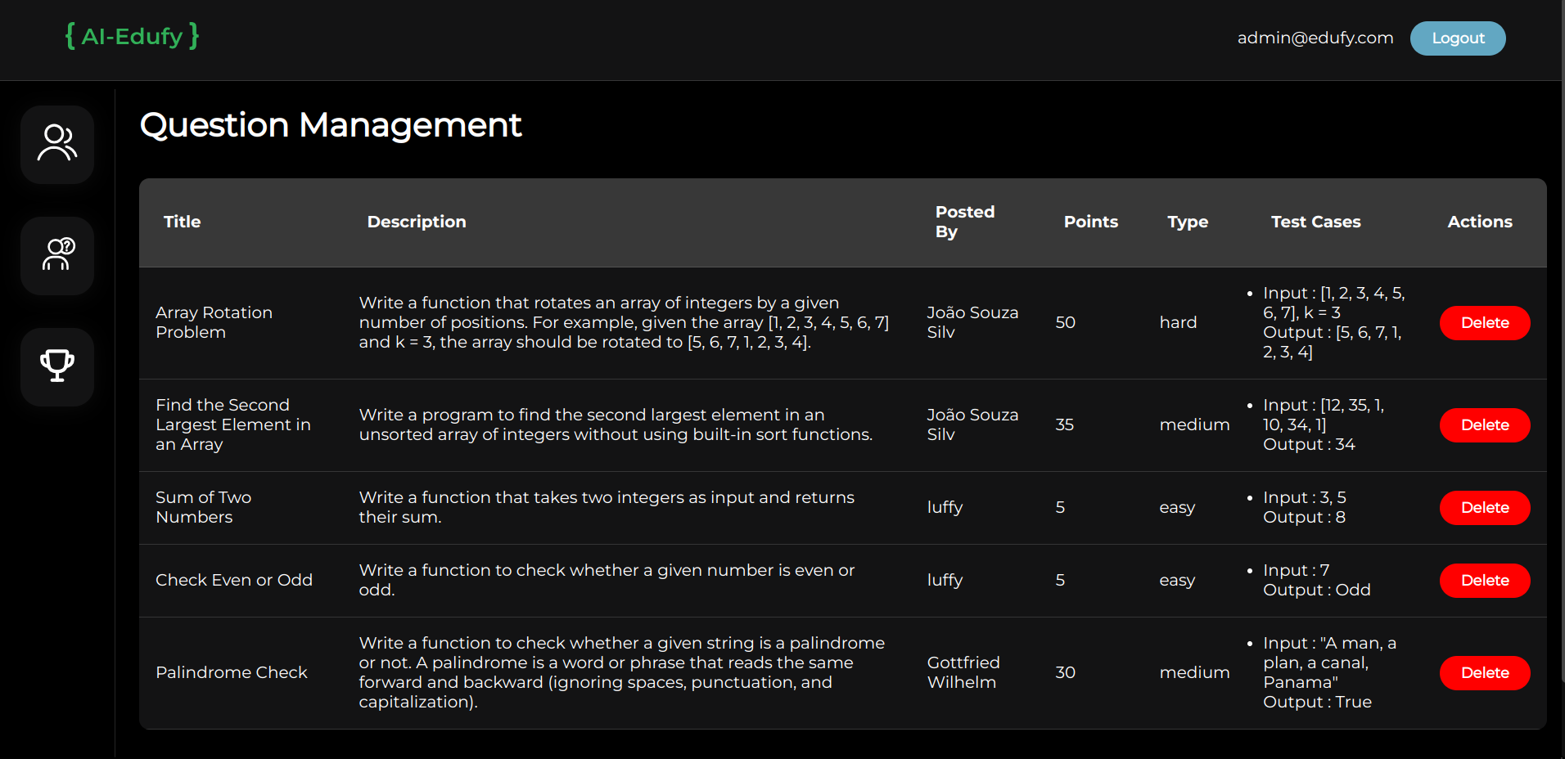

Admin Level Management Page

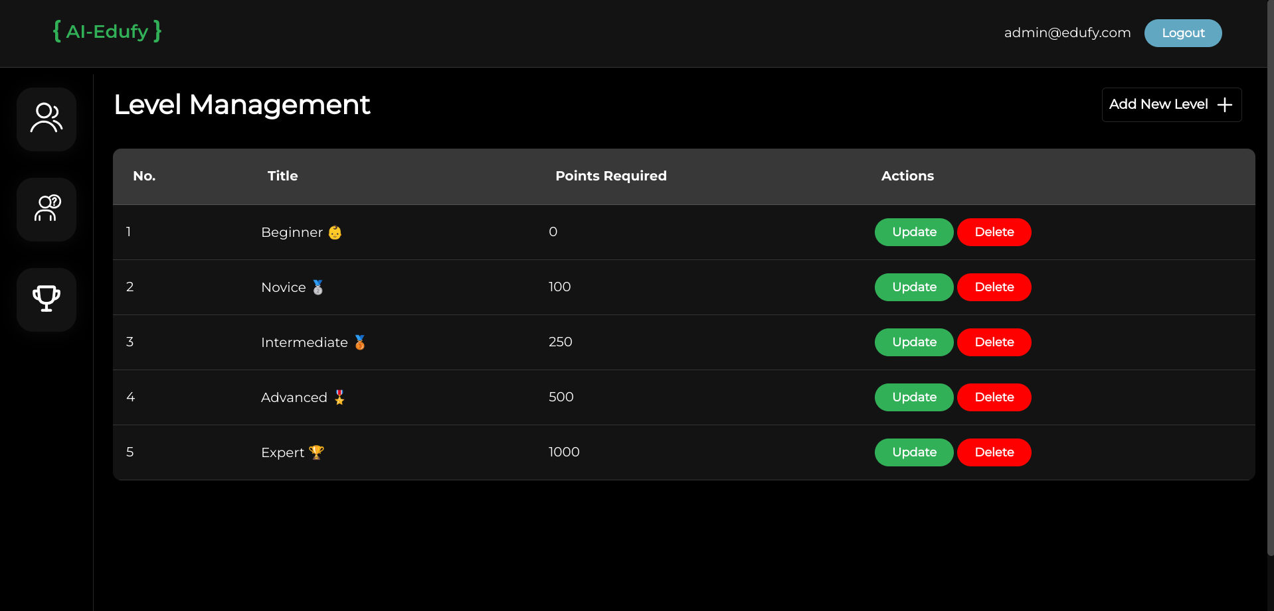

# 10. Bibliography

Books Referenced :

1. Google Gemini Documentation - <https://ai.google.dev/gemini-api/docs>
2. Database System Concepts (7th Edition) - Abraham Silberschatz, Henry F. Korth, and S. Sudarshan
3. Learning PHP, MySQL & JavaScript (5th Edition) - Robin Nixon
4. HTML and CSS: Design and Build Websites - Jon Duckett
5. JavaScript: The Definitive Guide (7th Edition) - David Flanagan
6. W3Schools - js , html , php , sql -<https://www.w3schools.com/>
7. Agile Software Development: Principles, Patterns, and Practices - Robert C. Martin
8. OneCompiler APIs docs -<https://onecompiler.com/apis/embed-editor>